**ADSBee m1090 Eval Board**

ADS-B Receiver Module Evaluation Kit

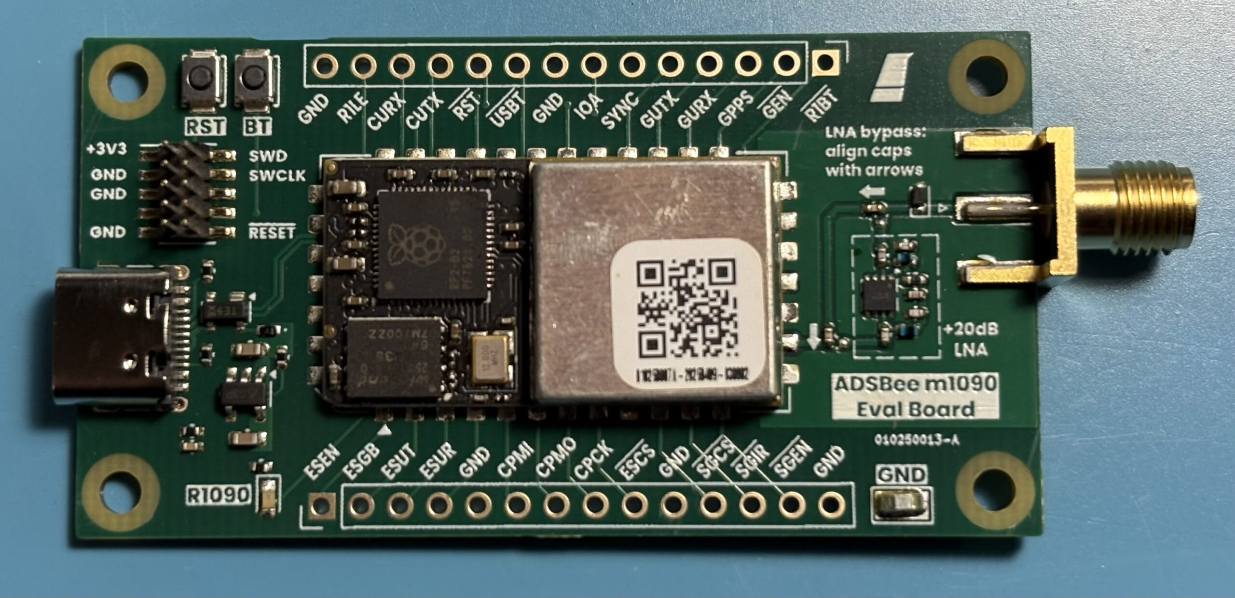

Features

* ADSBee m1090 receiver module with RP2040 and custom 1090MHz RF frontend.
* Can be extended to include sub-GHz reception and WiFi / Ethernet networking by connecting external evaluation boards.
* External LNA gain stage with configurable AC coupling caps (can be circumvented for reduced frontend gain and improved noise immunity).
* SWD debug header for RP2040.
* Boot / Reset buttons.
* 2.54mm Pin Headers for connecting external devices or measurement equipment.

Applications

* Evaluation of ADSBee m1090 receiver module for custom ADS-B applications.

Quick Specs

|  |  |
| --- | --- |
| Minimum RF Input Power Level | -90dBm (external LNA enabled)  -70dBm (default configuration) |
| Simultaneous Aircraft Tracks Supported | ≤400 |
| Connectors | 1090MHz RF In: SMA  Power / Data: USB C (5VDC)  Debug: 10-pin 1.27mm SWD |

Contents

Features 1

Applications 1

Quick Specs 1

Revision History 2

1 Overview 3

2 External LNA Bypass Configuration 4

3 Connecting External Evaluation Boards 5

3.1 Connecting an ESP32 Eval Board 5

3.1.1 ESP32 Dev Kit 5

3.1.2 ESP32 to ADSBee m1090 Pin Map 6

3.2 Connecting a CC1312R1 Launchpad 7

3.2.1 CC1312R1 Launchpad 7

3.2.2 Optional SYNC Line Resistor Mod 7

3.2.3 Optional SUBG_ENABLE Capacitor Mod 8

3.2.4 CC1312 to ADSBee m1090 Pin Map 9

# Revision History

20251231 – Initial release.

# Overview

The ADSBee m1090 Eval Board is the fastest way to try out the ADSBee m1090 module for your design application!

The board includes an external BLB01 LNA with configurable AC coupling capacitors, enabling the m1090 to be used with or without an external gain stage, as well as breakouts for each of the ADSBee m1090’s perimeter solder pads. External evaluation boards can be connected to these pin headers to enable Sub-GHz receive and network functionality.

Boot (BT) and Reset (RST) buttons on the edge of the board enable the m1090 module to easily be reset or entered into USB DFU mode without the need for re-plugging the USB C connector. In DFU mode, firmware can be loaded onto the m1090 module via the USB connection.

A 10-pin 1.27mm SWD header allows breakpoint debugging of the RP2040 on the m1090 module, or can be used to steal 3.3V for feeding external evaluation boards (the built-in AP2112K-3.3 LNA on the m1090 Eval Board can supply up to 600mA, which should be sufficient for the m1090 as well as an external ESP32 eval board and and external CC1312 eval board).

# External LNA Bypass Configuration

By default, the ADSBee m1090 Eval Board ships with the external LNA stage in the “bypassed” configuration, where two AC coupling caps divert the incoming RF signal onto a transmission line that circumvents the external LNA stage on the eval board. This default configuration is best for applications where signal strength is generally high, and reduced signal distortion at ultra close range is a priority (e.g. airborne detect and avoid applications).

The external LNA stage can be brought into the signal path by aligning the two AC coupling capacitors with the silkscreen arrows on the front of the PCBA. This is best done with a set of hot tweezers, or a hot air gun with a narrow nozzle. This will add +20dB of gain to the incoming signal, and is equivalent to the RF frontend configuration of the ADSBee 1090U. This extra gain stage is helpful in use cases where maximum range is required, at the cost of some signal distortion at ultra close range (e.g. ground station applications).

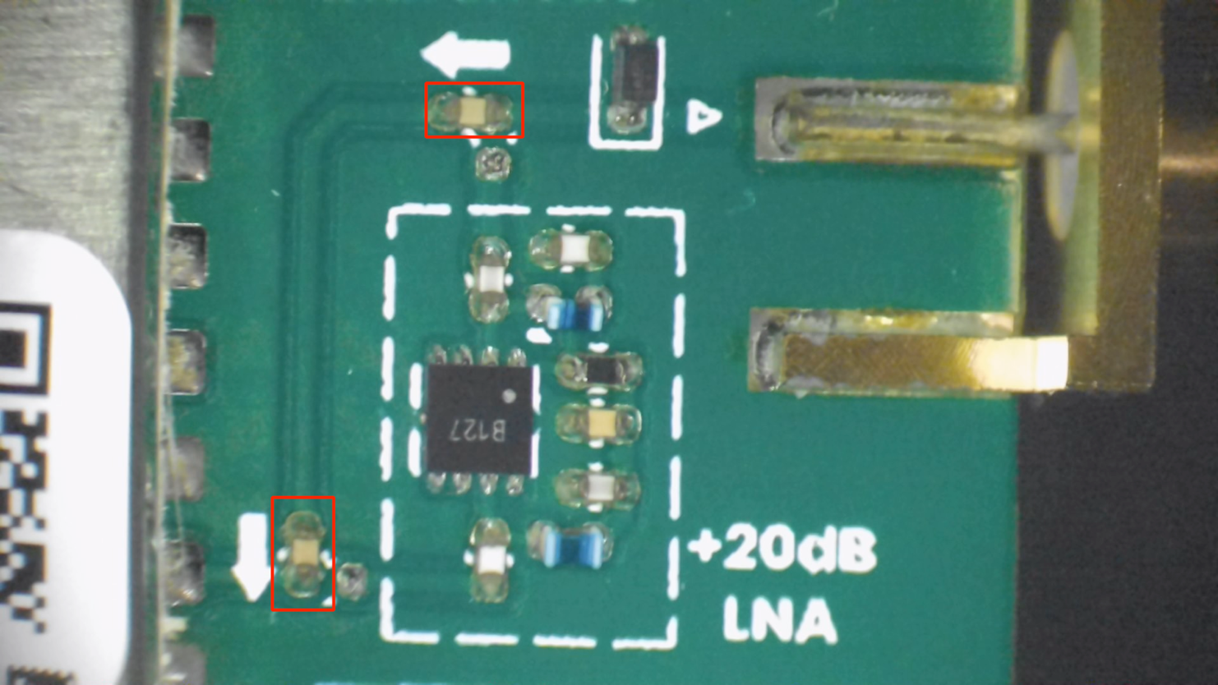

External LNA bypass caps shown in the default bypass configuration (boxed in red). To add the external LNA into the signal chain, pivot the bottom capacitor 90 degrees clockwise, and the top capacitor 90 degrees counter clockwise.

# Connecting External Evaluation Boards

The ADSBee m1090 Eval Board can be connected to external evaluation boards to add sub-GHz and network functionality via a CC1312 and ESP32 S3, respectively.

## Connecting an ESP32 Eval Board

The ADSBee m1090 Eval Board can program and communicate with an external ESP32 S3 module via its pin heads in order to allow wireless and wired networking functionality.

### ESP32 Dev Kit

The ESP32-S3-DevKitC-1 is recommended for use with the ADSBee m1090 Eval Board.

[Digikey Link (ESP32-S3-DEVKITC-1U-N8R8)](https://www.digikey.com/short/h8n9jdvv)

[Espressif Documentation Link (includes pin map)](https://docs.espressif.com/projects/esp-dev-kits/en/latest/esp32s3/esp32-s3-devkitc-1/user_guide_v1.1.html)

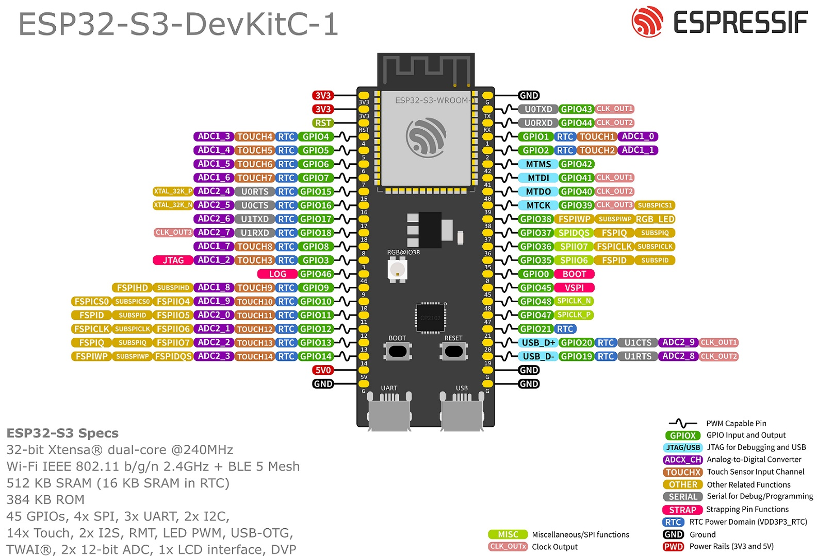

### ESP32 to ADSBee m1090 Pin Map

|  |  |  |  |
| --- | --- | --- | --- |
| **Pin Function** | **ADSBee m1090 Pin Name** | **ESP32 Pin Name** | **ESP32-S3-DevKitC-1U Pin Name** |
| Power Supply | +3V3 (stolen from SWD header) | 3V3 | 3V3 |
| ESP32 Chip Select | ~ESCS~ | GPIO39 | 39 |
| Coprocessor SPI Clock | CPCK | GPIO40 | 40 |
| Coprocessor SPI MOSI | CPMO | GPIO41 | 41 |
| Coprocessor SPI MISO | CPMI | GPIO42 | 42 |
| Ground | GND | GND | G |
| ESP32 UART0 RX (note this gets crossed over to TX on the ESP32 module itself) | ESUR | U0TXD | TX |
| ESP32 UART0 TX (note this gets crossed over to RX on the ESP32 module itself) | ESUT | U0RXD | RX |
| ESP32 GPIO0 / Boot Select | ESGB | GPIO0/BOOT | 0 |
| ESP32 Enable | ESEN | EN | RST |
| SYNC (optional) | SYNC | GPIO38 | 38 |

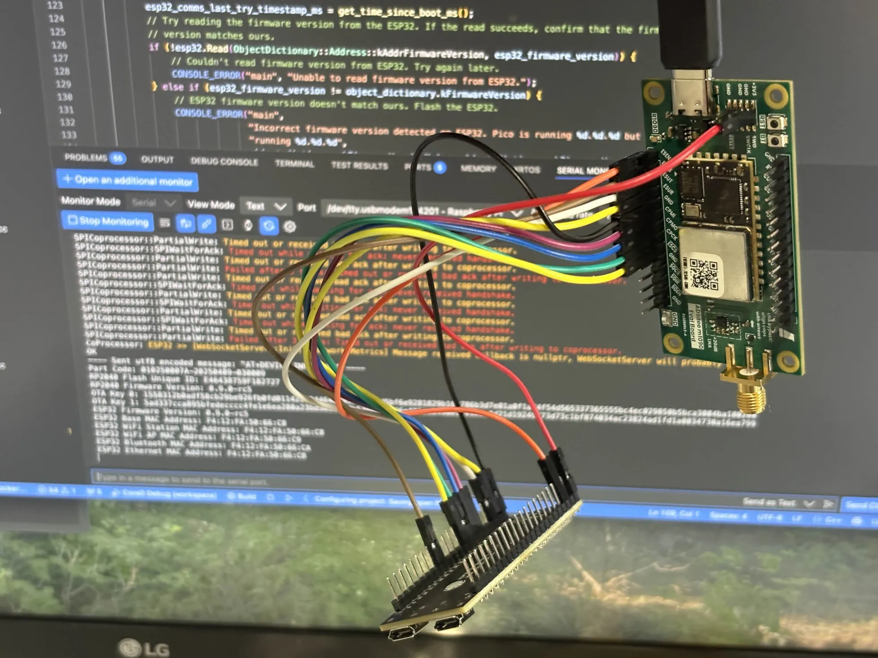

An Esp32-S3 DevKitC-1U attached to the ADSBee m1090 Eval Board. Note that these jumper wires are a bit long, and will negatively impact SPI bus signal integrity. Try using wires no more than a few inches in length, if you have them. In this image, the two boards worked when attached to each other, but when a CC1312R1 launchpad was added to the mix, the SPI bus was too gross to function properly. Shorter SPI wires routed close to a ground wire will help ward off signal integrity demons that could otherwise cause you some frustration.

## Connecting a CC1312R1 Launchpad

### CC1312R1 Launchpad

The CC1312R1 Launchpad is recommended for use with the ADSBee m1090 Eval Board.

[Digikey Link (LAUNCHXL-CC1312R1)](https://www.digikey.com/short/4h2jzrbz)

[Launchpad design file download link (includes schematic)](https://www.ti.com/lit/zip/SWRR160)

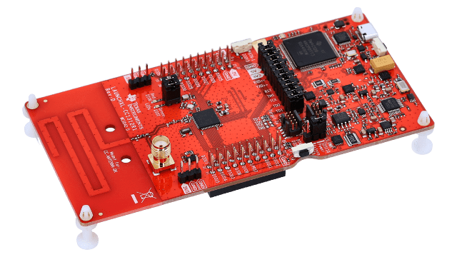

The TI CC1312R1 Launchpad. Note that jumpers connecting the CC1312R1 and the built-in debugger should be removed to enable the m1090 module to program and control the CC1312R1.

### Optional SYNC Line Resistor Mod

The CC1312R1 Launchpad includes a 3.3k pullup resistor on DIO5, which is used as the SYNC line on the ADSBee m1090. It is helpful to remove this resistor to ensure compatibility with the ADSBee 1090U schematic, but the launchpad will work with the m1090 eval board either way.

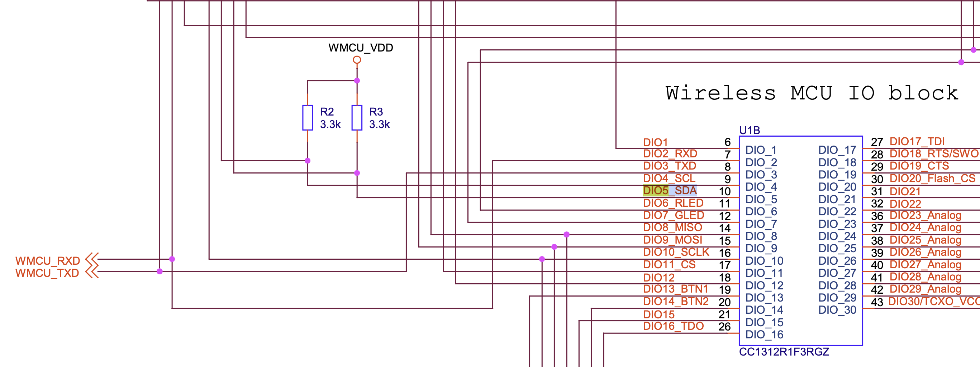 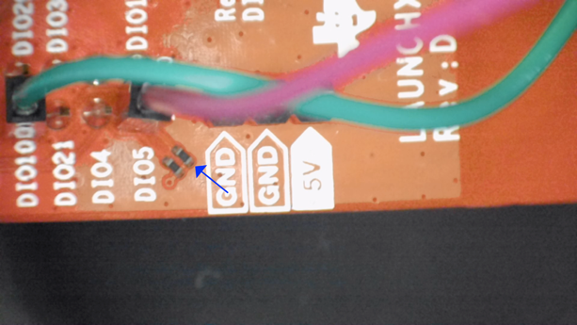

Left: CC1312R1 Launchpad schematic section showing 3.3k pullup resistor (R3) on DIO5. Right: Blue arrow indicates R3 on the CC1312R1 Launchpad, which should be removed.

### Optional SUBG_ENABLE Capacitor Mod

C52 on the CC1312R1 reduces the slew rate of the RST net compared to the 1090U. Removal of this part is optional, and is not required for firmware versions 0.9.0-rc6 and later (a delay was added to enable / disable actions). If the capacitor is not removed and a firmware older than 0.9.0-rc6 is used, the RST line will not slew down fast enough during a reset command, causing the ADSBee m1090 to be unable to consistently command the CC1312 into bootloader and operational modes.

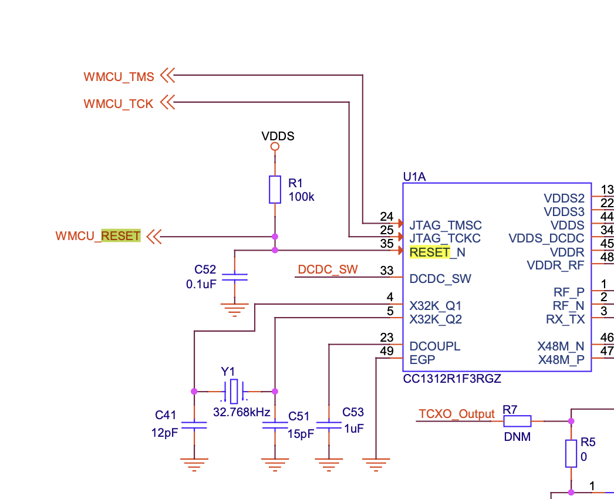 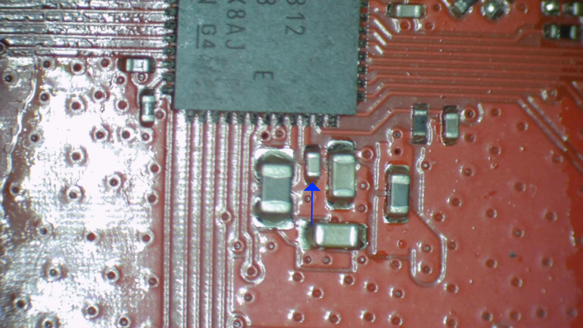

Left: Schematic showing C52. Right: C52 indicated with blue arrow.

### CC1312 to ADSBee m1090 Pin Map

|  |  |  |
| --- | --- | --- |
| **Pin Function** | **ADSBee m1090 Pin Name** | **CC1312R1 Launchpad Pin Name** |
| Power Supply | +3V3 (stolen from SWD header) | 3V3 |
| SubGHz Radio Chip Select | ~SGCS~ | DIO_11 |
| Coprocessor SPI Clock | CPCK | DIO_10 |
| Coprocessor SPI MOSI | CPMO | DIO_9 |
| Coprocessor SPI MISO | CPMI | DIO_8 |
| Ground | GND | GND |
| SubGHz Radio Enable | SGEN  (incorrectly labelled as ~SGEN~ on m1090 Eval Board PCB 010250013-A) | RST |
| SubGHz Radio Handshake | ~SGIRQ~ | DIO_18 |
| SYNC (required, since it’s used to select the bootloader state) | SYNC | DIO_5 |

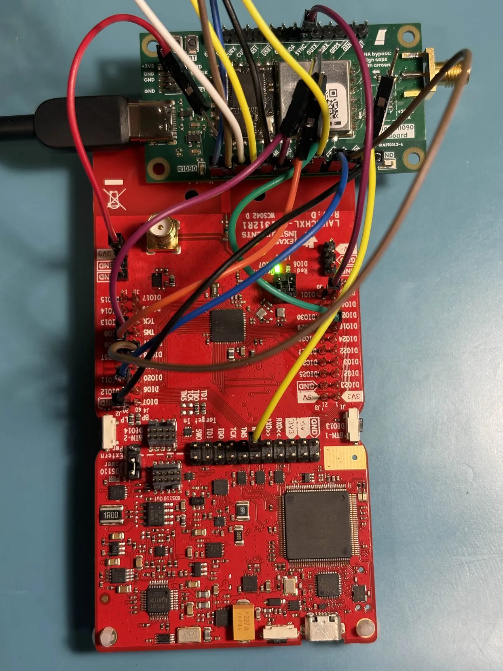

ADSBee m1090 Eval Board attached to a CC1312R1 Launchpad. Note that jumpers to the built-in debugger have been removed, and the launchpad is being powered by 3.3V stolen from the SWD header on the CC1312. Power can optionally be supplied via the Launchpad’s built-in Micro USB connector instead.